

JAVA PROGRAMMING
(340)

NATIONAL 2020

Production Portion:

Program 1: Fun Shapes (300 points)

TOTAL POINTS (300 points)

Judge/Graders: Please double check and
verify all scores and answer keys!

Property of Business Professionals of America.
May be reproduced only for use in the Business Professionals of America
Workplace Skills Assessment Program competition.

You will have 90 minutes to complete your work.

Your name and/or school name should not appear on any work you submit for grading. Write your contestant number in the provided space. Staple all pages in order before you turn in your test.

To submit your project:
- Create a folder on the flash drive using your contestant number as the name of the folder.
- Copy your entire solution/project into this folder, including source code.
- Ensure all the files required to run your program are present on the flash drive and will run on the flash drive.

Use the default package for the Java projects you create.
Fun Shapes

You have been hired by HasKids to create a small game for kids to play. This game lets kids click a button to create a random shape with a random color that appears in the game. They can also clear the screen of all shapes as well as toggle between filled shapes and outlined shapes.

General requirements:
- You must use JavaDoc for all methods in your program. It must cover what the method does and the inputs and outputs if there are any. JavaDoc is not required on the classes or variables.
- Your contestant number must appear in a comment near the top of your main class file, somewhere before the start of the main class.

Button requirements:
- All 3 buttons should be at the bottom of the window.
- The left button (Add Shape button) should add 1 shape to the screen. The shape’s requirements are listed below.
- The middle button (Clear button) should remove all shapes from the screen so that the next time the kid adds a shape, that shape will be the only one on the screen.
- The right button (Outline Mode button) should be a toggle button that, when enabled, makes all shapes, existing and new, be drawn as outlines. When the toggle button is disabled, all shapes, existing and new, should go back to being drawn filled. The button should start disabled (filled-in mode).

Shape requirements:
- Each shape should randomly be a circle or square when it is created.
- Each shape should have a completely random color with no transparency (alpha).
- The shapes should all have a random size. Choose values that make it obvious that the size and position are randomized.
- The shapes should be drawn above the buttons and should not overlap any buttons or go off-screen. They should be able to touch the edges of the canvas, though.

The main class of the program will be called Shapes.

Code requirements:
- You must use a SINGLE ArrayList to store the shapes (circles and squares). This keeps the overlapping order correct when drawing.
- You must use an ArrayList to store the shapes’ colors as java.awt.Color objects. The number of colors will match the number of shapes.
- The circles should be Ellipse2D.Float objects.
- The squares should be Rectangle2D.Float objects.
Sample Run (with many Add Shape button clicks)

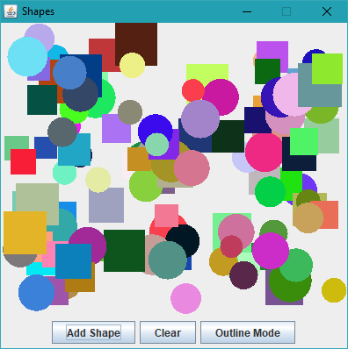

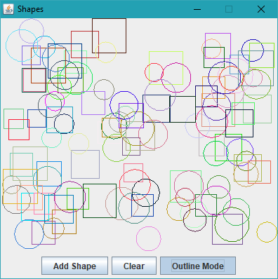
Notes to Graders
- As the shapes, their colors, their locations, and their sizes are all randomized, your outputs will not look exactly like the sample run.
- It is okay if the shapes are an overall different size than the ones shown as long as it is obvious that the sizes and locations are randomized.

Test Case
- Click the Add Shape button 10 times. Each click should add 1 shape with a random color, size, location, and shape (circle or square). The shapes should not overlap with any buttons nor go off-screen. They also should not have any transparency and should be filled in.
- Click the Clear button. All shapes should disappear.
- Click the Add Shape button 5 times. 5 shapes should appear filled-in. None of the previous shapes should appear.
- Click the Outline Mode button to enable it. All 5 shapes should now be outlined, not filled.
- Click the Add Shape button 5 times. All 10 shapes should be outlined.
- Click the Clear button. All 10 shapes should disappear.
- Click the Add Shape button 5 times. 5 shapes should appear and be outlined.
- Click the Outline Mode button to disable it. All 5 shapes should now be filled in.
- Click the Add Shape button 5 times. All 10 shapes should be filled in.
Solution and Project

The project is present on the flash drive. 10 points
The project’s main class is called Shapes. 10 points

Program Execution

The program runs from the USB flash drive. 10 points

If the program does not execute, then the remaining items in this section receive a score of zero.

All 3 buttons are present at the bottom of the window. 15 points

The Add Shape button creates shapes (no randomization required) and draws them on the canvas. 20 points
The shapes created have random sizes. 15 points
The shapes created have random locations. 15 points
The shapes created have random colors. All hues should be possible. 15 points
The shapes are randomly chosen between circle and square. 15 points
There is no transparency in any shapes when filled in. 10 points
The shapes never overlap a button and do not go off-screen. 20 points

The Clear button removes all shapes from the screen. 10 points
Adding a shape after clicking the Clear button only shows 1 shape, not any previously shown shapes, in the same drawing mode as before. 10 points

The Outline Mode button is a toggle button, not a regular button. 10 points
Enabling Outline Mode makes all shapes, existing and new, show only their outlines. 15 points
Disabling Outline Mode makes all shapes, existing and new, draw the shapes filled in. 15 points

Source Code Review

The contestant number is in a comment above the start of the main class. 10 points

A single ArrayList is used to store the list of shapes. 30 points
A single ArrayList<java.util.Color> is used to store the shapes’ colors. 15 points

JavaDoc is used to cover what each method does and the inputs and outputs if there are any. Not required on classes and variables. 30 points

Total Points = / 300 points

Suggested Solution
import java.awt.BorderLayout;
import java.awt.Color;
import java.awt.FlowLayout;
import java.awt.Graphics;
import java.awt.Graphics2D;
import java.awt.Shape;
import java.awt.event.ActionEvent;
import java.awt.event.ActionListener;
import java.awt.geom.Ellipse2D;
import java.awt.geom.Rectangle2D;
import java.util.ArrayList;
import java.util.Random;
import javax.swing.JButton;
import javax.swing.JFrame;
import javax.swing.JPanel;
import javax.swing.JToggleButton;

// Contestant Number = contestant number
public class Shapes extends JFrame
{
/**
* Runs when the program starts.
*
* @param args Input arguments when running the program. Not used.
*/
public static void main(String args[])
{
(new Shapes()).setVisible(true); // create the JFrame
}

/**
* Shapes constructor. Initializes JFrame and inner components (panel and buttons).
*/
public Shapes()
{
// Window-related stuff
super("Shapes");
this.setDefaultCloseOperation(JFrame.EXIT_ON_CLOSE);
this.setSize(400, 400);
this.setResizable(false);

// Panel for drawing
ShapesPanel pnl = new ShapesPanel();
pnl.setLayout(new BorderLayout());
this.add(pnl, BorderLayout.CENTER);

// Bottom panel for buttons
JPanel bottomPnl = new JPanel();
pnl.setLayout(new FlowLayout());
this.add(bottomPnl, BorderLayout.SOUTH);

// Button for creating shapes
JButton addBtn = new JButton("Add Shape");
bottomPnl.add(addBtn);
addBtn.addActionListener(new ActionListener()
{
@Override
public void actionPerformed(ActionEvent e)
{
pnl.addShape();
}
});

// Button for clearing shapes
JButton clrBtn = new JButton("Clear");
bottomPnl.add(clrBtn);
clrBtn.addActionListener(new ActionListener()
{
@Override
public void actionPerformed(ActionEvent e)
{
pnl.clearShapes();
}
});

// Button for switching between fill and outline
JToggleButton tglBtn = new JToggleButton("Outline Mode");
bottomPnl.add(tglBtn);
tglBtn.addActionListener(new ActionListener()
{
@Override
public void actionPerformed(ActionEvent e)
{
pnl.toggleMode();
}
});
}
}

class ShapesPanel extends JPanel
{
ArrayList<Shape> listShapes = new ArrayList<>();
ArrayList<Color> listColors = new ArrayList<>();
Random rand = new Random();
boolean fillMode = true;

/**
* Adds a new random shape to the list of shapes to draw.
*/
public void addShape()
{
int shapeInt = rand.nextInt(2);
float x, y, wh;
wh = rand.nextFloat() * 25 + 25;
x = rand.nextFloat() * (getWidth() - wh);
y = rand.nextFloat() * (getHeight() - wh);
switch (shapeInt)
{
case 0: // circle
listShapes.add(new Ellipse2D.Float(x, y, wh, wh));
listColors.add(new Color(rand.nextInt(16777216)));
break;
case 1: // square
listShapes.add(new Rectangle2D.Float(x, y, wh, wh));
listColors.add(new Color(rand.nextInt(16777216)));
break;
}
}

/**
* Removes all shapes from the board.
*/
public void clearShapes()
{
listShapes.clear();
listColors.clear();
}

/**
* Toggles between drawing filled shapes and outlined shapes.
*/
public void toggleMode()
{
fillMode = !fillMode;
}

/**
* Paints the panel with all the shapes in it.
*
* @param g The Graphics to use to paint the panel.
*/
@Override
public void paintComponent(Graphics g)
{
super.paintComponent(g);
Graphics2D g2D = (Graphics2D) g;

// Paint all the shapes
for (int i = 0; i < listShapes.size(); i++)
{
g2D.setColor(listColors.get(i));
if (fillMode)
g2D.fill(listShapes.get(i));
else // outline mode
g2D.draw(listShapes.get(i));
}

repaint();
}
}

